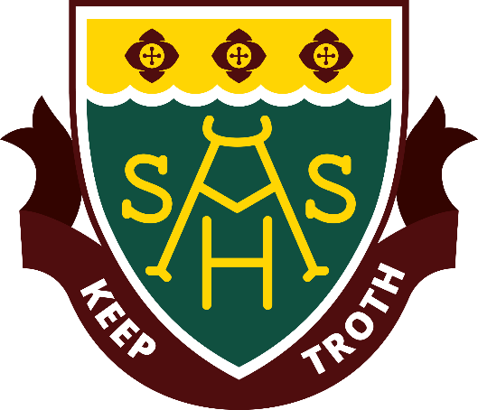

2026
Year 8
Curriculum Handbook

YEAR 8 COURSES 2026

Students in Lower School are required to meet educational outcomes across all learning areas. In Year 8 students are given some opportunity to choose which elective subjects they participate in. Students have the opportunity to experience a variety of courses which form the basis of elective subjects they might choose in Years 9 and 10.

In Year 7 and Year 8 students must study:

- English
- Humanities and Social Sciences
- Mathematics
- Science
- Health & Physical Education
  - Health Education
  - Physical Education

Students must choose at least one subject from each of the following learning areas during 2026:

Learning Area | Subjects
Visual Arts | Visual Arts, Media
Technologies | Woodwork, Metalwork, What’s Cooking, Fabulous Food, Lego
Performing Arts | Drama, Pop Band, Class Music
Language | Indonesian, Noongar

LEARNING AREA: LANGUAGES

The language you choose will depend on your interests and future goals in life. You can choose to continue with your language from primary school or you can choose to try something new.

At Albany Senior High School, we offer two languages – Indonesian and Noongar.

All courses will cater for both beginners and those who are continuing a language from primary school. However, it is recommended that you only change languages if you have a genuine interest in the alternative language that is being offered. The language you choose will be studied from Year 8 to Year 9. You will also have the choice to continue your language through to upper school. There are many opportunities for language learners; these include travel tours and student exchanges. We look forward to welcoming you to our department.

In languages students will learn the basics of speaking, reading and writing in a variety of practical everyday situations.

LEARNING AREA: LANGUAGES

Indonesian

Semester 1 and/or 2

Learn the language and aspects of the culture of Australia’s closest neighbour!

As a popular holiday destination for many Australians as well as being a valuable trading partner, there are strong links between Australia and Indonesia. Indonesian language skills can open doors to a range of employment opportunities in the future.

Noongar

Semester 1 and/or 2

Kaya…

Language is culture, culture is language.

Immerse yourself in the Language and Culture of the Noongar people and the Menang Boodja (land) on which we live and learn.

LEARNING AREA: THE ARTS

Visual Arts

Semester 1

Explore, experience and express creativity through a variety of art forms, such as painting, drawing, printmaking and clay work. You will be introduced to a range of historical and contemporary artistic styles.

Visual Arts

Semester 2

Explore, experience and express creativity through a variety of art forms, such as painting, drawing, printmaking and clay work. You will be introduced to a range of historical and contemporary artistic styles. Semester 2 will focus on different mediums and techniques to cater for those students wishing to participate throughout the year.

Media

Semester 1 or 2

Explore and produce your own short films, photographs, advertisement and modern media. Develop your production skills through collaboration and use of editing software such as Photoshop.

Semester 2 will be a REPEAT of the Semester 1 course. Only select Media in either Semester 1 or Semester 2.

Performing Arts - Drama

Semester 1 and/or 2

Enter stage left! You will enjoy creating your own dramatic works and learning the art of improvisation. You will develop your performance skills and engage in basic script work, theatre etiquette and production skills.

Pop Band

Semester 1 and/or 2

Release your inner rock god, teen popstar or alt rock superstar. Develop skills for the contemporary music scene, including stagecraft, performance, microphone technique, managing amplifiers and effects.
A performance-based course that will include in-class and public performances. Previous musical skills are highly beneficial.

This is a Semester 1 and 2 course. Students can select either Semester 1 or 2 or both semesters.

Class Music

Semester 1 and 2

Total Cost: $40

Class music empowers you to be an active and knowledgeable participant in the music industry, from classical music through to hip hop, electronic, and film music. Practical music-making, composition activities and analysis skills exploring the cultural context of musical styles are covered.

This course is compulsory for all students enrolled in the Instrumental Program and must be selected both Semester 1 and 2.

Instrumental and Ensemble Music

Semester 1 and 2

Total Cost: $40

All students receiving a lesson through the IMSS scholarship program are enrolled in this course. In this course you will receive your free group lesson on woodwind, brass, strings, guitar, voice, or percussion/drums, as well as participate in your compulsory musical ensemble (Concert Band, Orchestra, Guitar Ensemble, Choir, Rock Band). Ensembles give the student the opportunity to be involved in performances, camps and tours, as well as other social opportunities. Ensemble rehearsals occur outside of school hours, and instrumental lessons take place on a rotational system across the school day to minimise disruption to academic classes. Inclusion in the IMSS Instrumental Scholarship Program at ASHS requires the student to also enrol in Class Music.

LEARNING AREA: TECHNOLOGIES

What’s Cooking

Semester 1

Build you cooking skills, as you explore food and techniques to prepare great tasting food and meals for yourself and your family.

Fabulous Food

Semester 2

Be creative and try new taste sensations! Learn how to choose, plan and prepare delicious meals, for fun and health. Explore some different or unfamiliar ingredients to challenge your tastes.

Woodwork

Semester 1 or 2

Get creative with wood, develop your skills using both hand tools and larger woodwork equipment to produce wood projects.

Semester 2 will be a REPEAT of the Semester 1 course. Only select Woodwork in either Semester 1 or Semester 2.

Metalwork

Semester 1 or 2

Explore metals, both fine and heavy, as you develop your skills and understanding when working with various metals as your material.

Semester 2 will be a REPEAT of the Semester 1 course. Only select Metalwork in either Semester 1 or Semester 2.

Lego Robotics

Semester 1

An introduction to the world of robotics using Lego. Develop programming skills to make your robot perform.

Lego League

Semester 2

Create and program your team's robot to complete a specified challenge. Top teams will compete in the Lego League challenge.

